**Data Visualization Research using Tableau**

**‘Best Superstore’**



ST 2187 Business analytics, applied modelling and prediction

Student Number: 200615086

**Executive Summary**

In this world where vast amounts of data are pouring out every day, all companies are committed to collecting and analyzing data. If any company lags a little behind in this competition, it will be difficult to survive in the market because they will become weak in an instant. The subject of this research, ‘Best Superstore’, also has a lot of concerns about the future. They are in the situation which hope to describe the key insights with raw data they have now and get recommendations accordingly. Upon the request from ‘Best Superstore’, this study will provide five overviews of data analysis.

The following is a brief introduction to five overviews.

Firstly, the Monthly Overview is an analysis of how data has changed over time. The key insights of first dashboard will be to identify the store’s performance in the short and long term, the degree of growth from the past and growth potential in the future. The recommendations that can be given to senior management will be to respond to the future based on the evaluation of the past.

Secondly, the Customer Overview is an analysis of customers who use the store. This overview mainly tried to see customer retention, one of the KPIs. It is much more efficient marketing to promote existing customers to revisit than to create new customers. Therefore, this dashboard will show the segmentation of customers and the status of repurchase (retention). Also, it will identify by applying the Pareto Principle how much profit a minority of customers account for.

Thirdly, the Product Overview is an analysis of products sold in the store by category. Since profits will vary widely for each product sold, this dashboard will describe whether there is a profit-making pattern for each category. This pattern can also be explained through categories of top and bottom products in sales or profits. Through the analyzed pattern, senior management can predict profits by category and establish marketing strategies accordingly.

Fourthly, the Market Overview is an analysis of differences in sales or profit between regions. Consumption patterns and customer segments differ depending on the continent, country, and region where they live. Therefore, the sales method and strategy should be approached differently according to regional characteristics. The differences found in this dashboard will be a regional characteristics and key insights, and it will be easy for senior management to generate profits if they thoroughly conduct market research.

Lastly, the Shipment Overview is an analysis of delivery to customers. More and more customers want fast delivery, and delivery has a great impact on consumer satisfaction. This dashboard regarded ‘Same Day’ and ‘First Class’ as fast delivery and will find out what features are in the orders delivered by fast delivery. Senior management can manage ship mode according to its features.

In conclusion, this research will find key insights in each overview and promote the success of the ‘Best Superstore’ through the recommendations based on the analysis.

Table of Contents

1. Introduction4
   1. Background4
   2. Current issue4
   3. Scope of study4
2. Methodology5
   1. Purpose of research5
   2. Approach5
   3. Source of data5
   4. Data analysis5
3. Data Analysis6
   1. Monthly Overview6
   2. Customer Overview7
   3. Product Overview8
   4. Market Overview9
   5. Shipment Overview10
4. Conclusion11
5. Word Count11
6. Appendix11
7. Introduction
   1. Background

‘Best Superstore’ is an e-commerce store located in the United States. They sell products not only in the domestic market but also around the world via online, and there are various items that they handle. However, as most businesses progress online, barriers to entry have been lowered, resulting in numerous entries and exits to the market, and it has become increasingly difficult to cope with new competitors. With a rapidly changing society and an unpredictable environment such as viruses and disasters, it has also become difficult to analyze consumer patterns.

* 1. Current issue

Achieving from small goal to huge objective is a success of company they think, but it is not easy to survive, let alone succeed in the market these days when all situations are uncertain. To solve it, management mainly uses the Key Performance Indicators (KPIs) to help them achieve their goals. *(Lewis, n.d.)* The role of the KPIs presents future directions like a compass and provides objective standards that all members of the organization can understand. Therefore, senior management currently needs key insights to achieve corporate objectives and need predictions and recommendations to prepare for an uncertain future.

* 1. Scope of study

This research will cover order data of ‘Best Superstore’ from 2017 to 2020. A total of 51,290 order data will be expressed and analyzed through various diagrams and charts to find key insights. In this study, data such as ID, customer name, and postal code were not used because they were deemed unnecessary for analysis, and six orders at the end of December 2016 were judged to be insignificant data that did not affect the analysis, so they were filtered in some dashboards.

1. Methodology
   1. Purpose of research

The purpose of this research is to provide key insights by analyzing and visualizing order data received from ‘superstore’ using Tableau, and to give recommendations to senior management based on key insights.

* 1. Approach

This study is inductive research because it is an approach to analyze the currently existing data to find patterns and derive theories and solutions.

* 1. Source of data

This study uses internal records of the store. This corresponds to secondary data. It has the advantage of being able to collect data quickly and easily and being lower cost than primary data.

* 1. Data analysis

There are five overviews in the data analysis of this study. The five overviews are 1) Monthly Overview, 2) Customer Overview, 3) Product Overview, 4) Market Overview, 5) Shipment Overview.

1. Data Analysis
   1. Monthly Overview

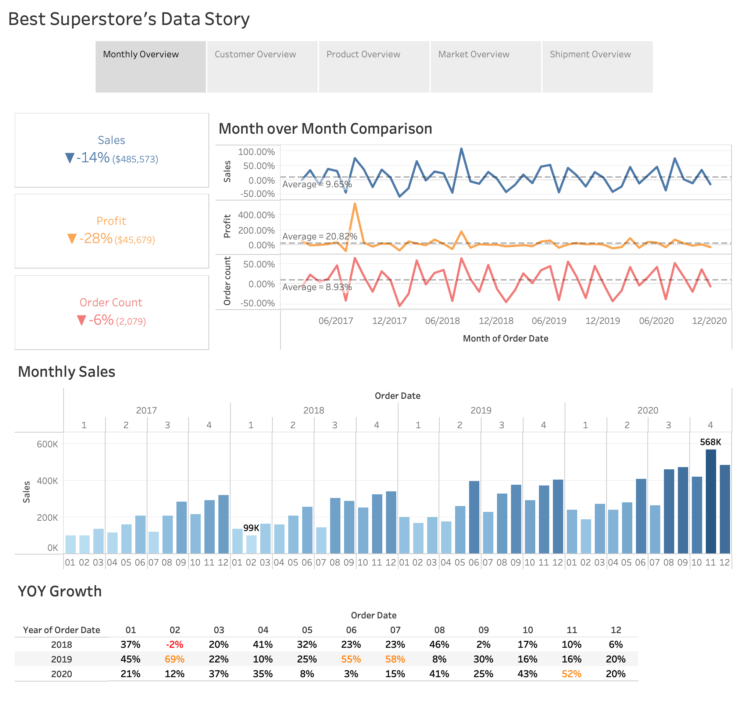

The first dashboard is the Monthly Overview. First, looking at the three summary tiles at the top left, they indicate how much the most recent month has increased or decreased compared to the previous month. Tiles can grasp the current performance immediately from a short-term perspective. Next, Month-Over-Month Growth (MoM) was used to see from a long-term perspective. MoM shows a similar pattern of sales and order count going up and down, while profit is steady except for some months. Monthly sales show the values of sale for all months. As you can see the bar chart, you can see that sales are steadily growing. Lastly, Year-Over-Year Growth (YoY) is a comparison of specific month with the previous year. Simply comparing sales to a month ago is not a sophisticated analysis. Therefore, by comparing a specific month with the previous year, it can be seen through YoY growth whether the month’s sales can be viewed as actual performance. According to the Monthly Overview, sales are increasing, but profits were almost appearing to be unchanged. Therefore, the senior management should fret how to increase profits in the future.

* 1. Customer Overview

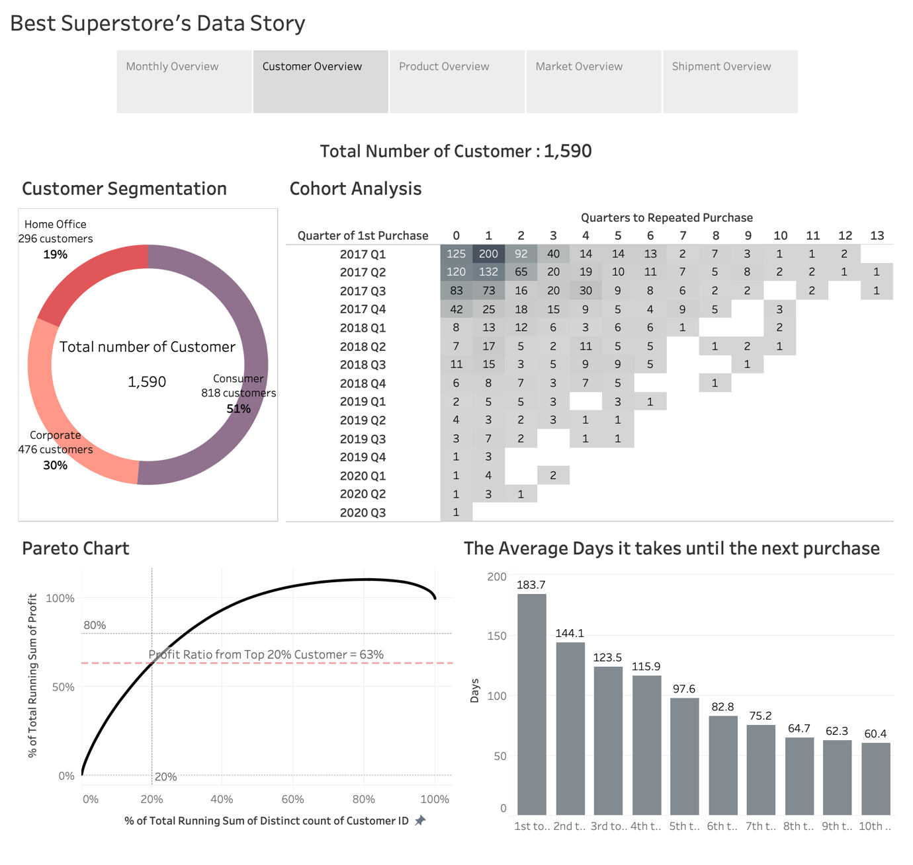

The second dashboard is an overview that analyzes customers using the store. First, looking at customer segmentation, a total of 1,590 customers can be classified into three segments. It consists of a Consumer that occupies a majority, followed by a Corporate and a Home Office. Next, the cohort analysis is an indicator of the period it took for the user to repurchase. After the first purchase, the next purchase is continuing rapidly overall. The line graph below it is a Pareto chart. It is a graph created to prove the Pareto Principle, usually called ’80-20 rule’. It refers to a phenomenon in which 80% of all results occur in 20% of all causes. *(Laoyan, 2021)* As a result of apply this principle to ‘Best Superstore’ to see how much sales 20% of customers accounted for, they occupied for 63% of all profits. This means that profits are not biased to specific customers and the range of customer is wide. The last bar chart is for viewing the days of purchase according to the number of purchases. The more purchases, the shorter the days it takes to make the next purchase. Through the Customer Overview, it is necessary to find ways to increase customer retention and marketing that can lead to next purchases.

* 1. Product Overview

The third dashboard is the Product Overview. The large-looking letters are called word cloud, and the name of the sub-category is expressed in a different size and color. The larger the size, the more sub-category sold, and the color means category. Next to the word cloud, there are profit, sales and average discount by sub-category. The sales of ‘Tables’ are average compared to other categories, but it is the only loss. Considering that the average discount of ‘Tables’ is the highest, the reason for the only deficit is that there are many discounts. Lastly, ‘Phones’ in technology occupies most of the top 10 in sales, and ‘Technology’ also occupies most of the top and bottom 5 in profit. As a result, products of technology bring a lot of sales, but there is a large variation in profit. Discount rates have a great impact on profits. The ‘Best Superstore’ should ensure that products maintain an appropriate discount rate. And products of technology are highly sold but sensitive to trends. Always keep in mind that it is a short-term sale.

* 1. Market Overview

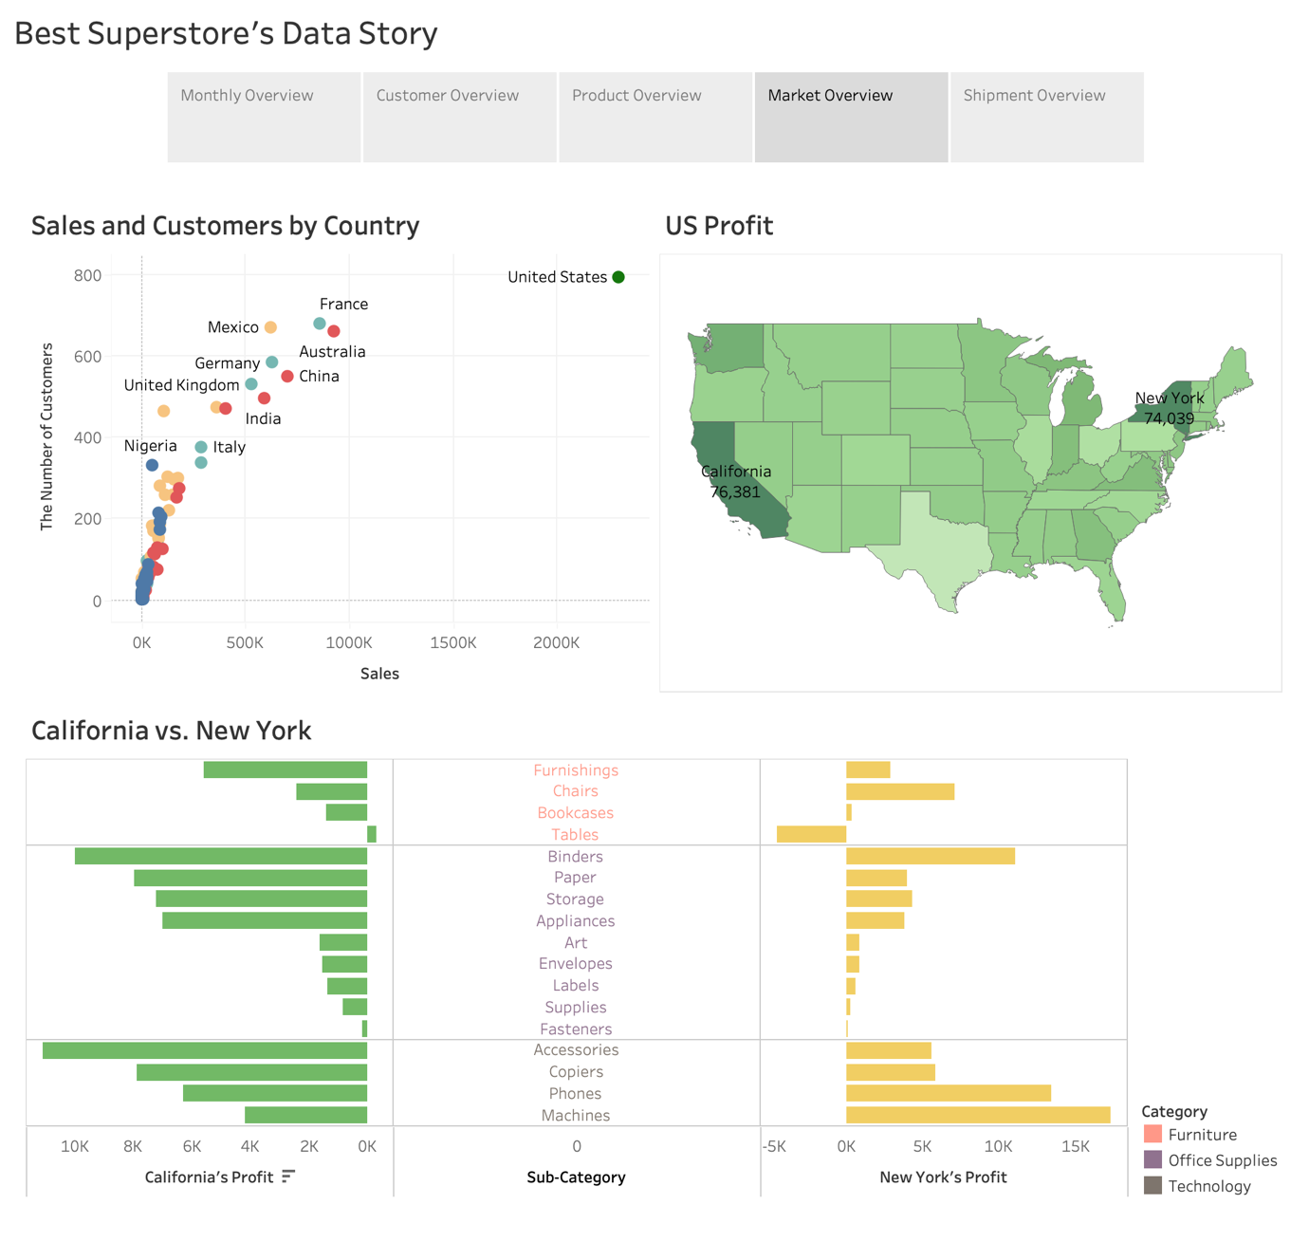

The fourth dashboard is the Market Overview that can be compared by country and region. First, since the ‘Best Superstore’ is in the United States, sales and customers in the United States were the highest in the world. European countries and APAC countries followed, and African countries had relatively low sales and customers. Next, to figure out in more detail, the United States, which has the largest number of customers, was divided by state, and expressed as a heat map so that the higher the profit, the darker color. California and New York have been shown to bring relatively high profits. Thus, those two states’ profits were compared by sub-category. In the butterfly chart, California has higher profit in ‘Office Supplies’ than New York, but lower in ‘Machine’ and ‘Phones’. Accordingly, senior management should not only establish marketing strategies only based on the country, but also approach in various ways according to the characteristics of the region in detail.

* 1. Shipment Overview

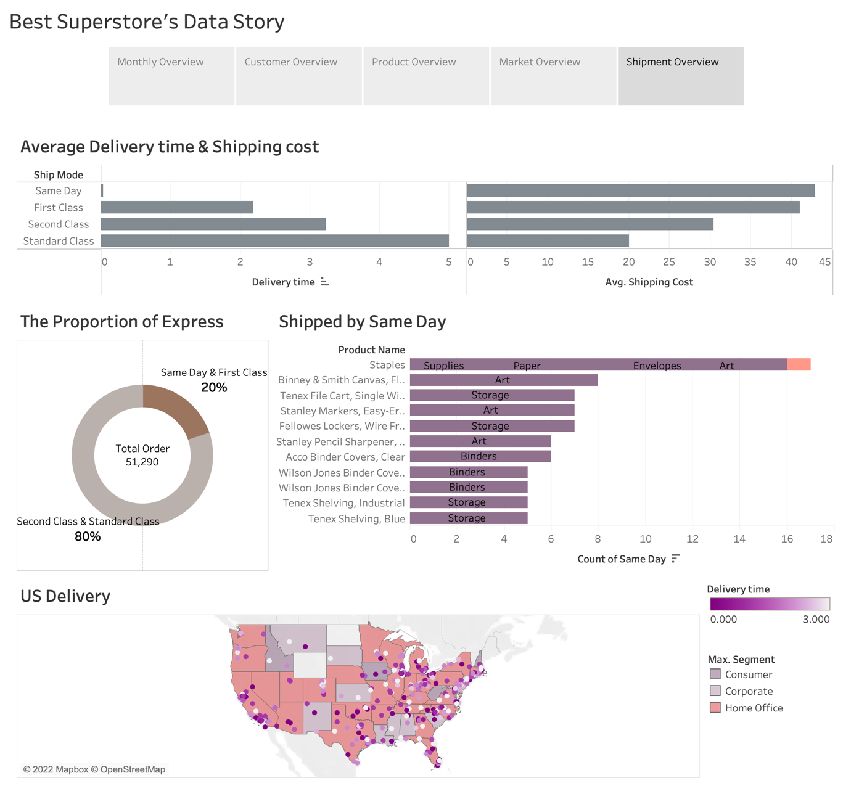

The last dashboard is the Shipment Overview that deals with the tendency of delivery to customers, the last step in ordering. The bar chart on top is the average delivery time and cost according to the ship mode. Naturally, the shorter the delivery time, the more expensive the delivery cost is. However, it should be aware that the difference in average shipping costs between ‘Same Day’ and ‘First Class’ is less than $2. Next, the pie chart shows that the ratio of high-class ship mode and low-class ship mode is two to eight. And as a result of analyzing the products ordered by the same day ship mode, it was found that almost all products were office supplies. The heat map below expressed a different color for the segment ordered the most among the mode of same day and first class, and most of them were customers of home office. There was various delivery time from very day to three days. These days, as online consumption is increasing, delivery has a great influence on customer satisfaction. Senior management needs to respond to customers’ demand for fast delivery.

1. Conclusion

Simply looking at the raw data, management can say that the performance of the ‘Best Superstore’ is fine because there are many orders and profits are positive, but when analyzing and visualizing in detail, there were shortcomings and things to be improved. Senior management is expected to achieve their objectives if key insights are well applied to management and some recommendations are executed.

1. Word Count

Excluding the executive summary and a table of contents, the word count of the research so far is 1422.

1. Appendix

Lewis, J., n.d. *What Are Key Performance Indicators & What Role Do They Play in the Strategic Planning Process?*. [online] Small Business - Chron.com. Available at: <https://smallbusiness.chron.com/key-performance-indicators-role-play-strategic-planning-process-31851.html>.

Laoyan, S., 2021. *Understanding the Pareto Principle (The 80/20 Rule) • Asana*. [online] Asana. Available at: <https://asana.com/ko/resources/pareto-principle-80-20-rule>.